**DOM (Document Object Model)**

* It is an API (Application Programming Interface) for manipulating HTML and XML documents.
* It can add, remove or modify parts of HTML documents.

When a page is loaded, the browser creates a Tree like structure called DOM tree of the HTML page.

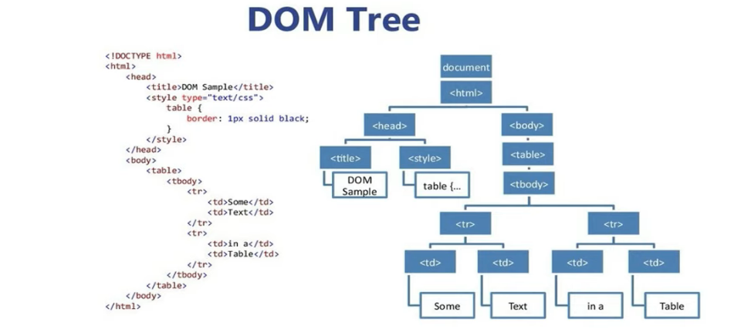

* Here every tag acts as an Object and has some properties and method associated with it which can be manipulated using Javascript.
* The Document tag is the root node/ Object and every other objects are properties of it.
* The Document represents the webpage.
* If we want to access any element in webpage, we always start with Document Object.
* This tree structure is required to easily find Objects to manipulate them.
* With the help of Object Model , Javascripts gets all power to create dynamic HTML.
  + Javascript can change all HTML elements
  + Javascript can change all HTML attributes
  + Javascript can change all CSS style
  + Javascript can change all HTML elements
  + Remove existing HTML elements/attributes
  + Add new HTML elements/attributes
  + Reacts to all existing HTML events
  + Create new HTML events